15.47: a)
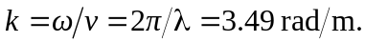
b)

c)At From this form it may be seen that at 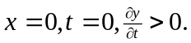 d) At 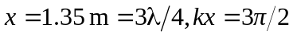 and
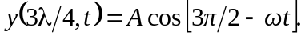

e) See Exercise 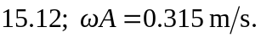 f) From the result of part 